BASIC CONSERVATION
WORKSHOP
2011

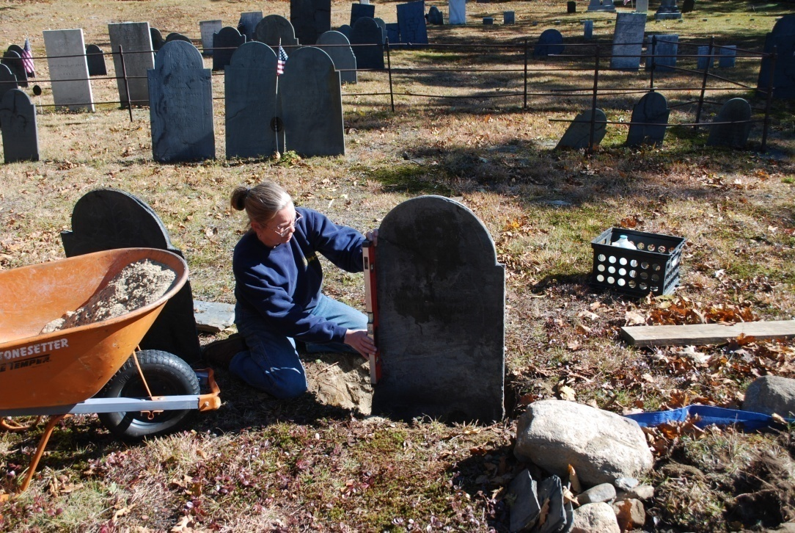
HISTORIC GRAVESTONE SERVICES
New salem, ma
www.historicgravestone.com

Basic Conservation

What is the difference between a rock and a stone?
Types of stones Sedimentary, metamorphic, and igneous
Sedimentary accumulation and consolidation of sediment usually in layered deposits like sandstone, limestone and shale
Metamorphic alterations to the minerals, texture and composition of a rock caused by exposure to heat, pressure and chemical actions. Shale to slate, limestone to marble and sandstone to schist
Igneous crystallization of magma or lava into rocks like granite, basalt or gabbros
What is a gravestone?
Marker, monument or artifact?
A gravestone serves to mark the location of a burial, or as a memorial to those whom may or not be buried there and after time become artifacts from another era. They command respect no matter what its purpose or age.
Types of markers – fieldstone, tablet, die and base, obelisk, pedestal with base, box tomb, cairn, table tomb, monument with cribbing, ledger or wolf stone, mausoleum,
Carvers - just a few words about carvers and signatures…….always look for signatures and carver’s marks. Record this information on the conservation form
Who does it belong to?
When a stone is purchased and placed at a sight, it is the property of the family which owns the plot. The grounds are maintained by the company or town which oversees the cemetery, but the stone remains the property of the family and the descendents. Ancient burial grounds, pioneer and family cemeteries, churchyards and abandoned cemeteries can fall under the care of Historical Societies or commissions. Historical groups will work to preserve the entire cemetery including the gravestones and structures which are viewed as historical artifacts.
Who should repair gravestones?
An individual should first have the proper training and permission. Cleaning and simple resets of family stones or as part of a conservation project can be performed by physically able and knowledgeable volunteers, however public safety is priority. Many repairs require a conservator to be done properly. Be sure to interview all potential conservators and check references!

Why should gravestones be cleaned?
Biological growth and ambient soiling will obscure important details and are detrimental to the stones longevity. Biological growths like algae, moss and lichen can consume the rock and cause a loss of material on the surface as well as conceal other problems; i.e. missing mortar, pests, water damage. Removal of biological growth and a gentle cleaning can be helpful in extending the life of the monument and improve its appearance.
Be aware that stones which have been exposed to the elements for years will likely have soiling and stains which are difficult to remove, if not impossible. Some stones are old and fragile and unable to withstand a more aggressive cleaning. It is okay if they are not fully restored to their former glory, but that they are maintained and appreciated.
Where do I start?
Once a project has been initiated and proper permission has been secured, the first step is to create a project plan. Work should not begin until there is a clear plan. Beginning with a stone by stone assessment, document the names, dates, inscriptions, and condition. Documenting forms should contain the location of cemetery, lot numbers, type of stone, monument style, inscription, condition and date of assessment. Document the stones with before and after photos. The plan will develop quickly and a priority list will emerge. The project can then easily move forward once there is a plan and a priority list.
What is wrong with this stone?
Assessing the stone properly will determine which treatment is correct. A stone which is leaning front to back is at more risk than a stone which is tilted side to side and therefore should be prioritized as such. A larger stone which has a 20% lean is at more danger than a small stone which has a 40% lean. A stone which has broken and is on the ground – is at risk of further damage and may be a high priority. A priority list should be generated from the assessments using the following criteria:
Priority List
#1 Public Safety Can the stone fall on someone or trip them?
#2 Stone Safety Is the stone in danger of falling or suffering further damage?
#3 Historical Value Is the stone for an early settler in the town or important figure in history? Is the stone unusual or hand-carved, maybe from another era?

HISTORIC GRAVESTONE SERVICES *Conservation Form* TLC* 2011
Cemetery
Location
Record Date
Name
Date of Death

Material
Marker Type
Base
Orientation
Dimensions
No. Commemorated
Carved Surfaces
Stone Carver
Motif
Border
Carving Condition
Inscription

Previous Work
Stone Condition
Recommendations

TOOLS
Cleaning WATER, WATER, WATER
Buckets
Soft natural or nylon scrub brushes
Craft sticks
Plastic wrap/garbage bags
Photoflo
Ammonia
D-2 or Bio-wash
Elbow Grease

Resetting a Tablet Stone
Shovel
Wheelbarrow
Plastic Garden Trowel
Milk Crate
Tarps
Tape Measure
Level
Sand and Gravel
Pry Bar
Tamper
Wood for support, tamping and bracing
Water for compacting sand & gravel

Resetting Tablet in a Base
Mason Trowels
Pointing tool (flexible blade)
Mixing Bucket
NHL (naturally hydrated lime)
Masonry Sand
Portland cement
Water

Recommendations for cleaning old gravestones in-situ

When preparing to clean a stone ensure that it is stable. Visual observation comes first. Then GENTLE hands-on to test and confirm observations. Always stand or kneel to the side of the stone while applying solutions and scrubbing. Do not lean on the stone while cleaning. Should the stone prove to be unstable despite earlier precautions, potential personal injury will be avoided. Safety should be a priority.
#1 Cover all neighboring gravestones with plastic bags to protect them against splashing while cleaning.
#2 For all types of stones, dry brush the entire stone with a soft bristle brush to remove loose material such as moss, lichens or grass clippings before wetting.
#3 Always start to wet the stone with water at the bottom first and work your way up. Wet the stone thoroughly with water then begin scrubbing at the bottom of the stone; this will prevent streaks from the dirty water. Rinse with water frequently until the water runs clean from the stone.
#4 For slate, limestone, marble and granite – mix one ounce Photoflo (available at camera supply stores) in five gallons of water. Obviously you can reduce the proportions to meet the needs of your particular project. Wet the stone with this solution (starting at the bottom), scrub, and rinse with clean water. The solution will produce suds, but it is NOT SOAP.
#5 For slate, limestone, marble and granite – mix one-half cup of household ammonia into one gallon of water. Wet the stone with this solution (starting at the bottom), scrub, and rinse with clean water. Ammonia is non-hazardous to the stone or the environment. BLEACH SHOULD NEVER BE USED.
#6 For biological growths, such as lichens or moss, use an agent like D-2 or Bio-wash designed specifically for biological growths on stone. Follow the manufacturer’s directions.
#7 Some lichen, black in particular, is very resistant to the above procedures. If necessary, the affected area can be treated with a poultice made from powdered clay (kaolin) mixed to a paste using equal parts of water and glycerin. Apply to moist stone and wrap with plastic to keep moist and leave for a day or two. Remove poultice and rinse well with clean water. This should remove most all lichens.

PROCEDURES FOR RESETTING A STONE

Resetting a Tablet Stone
#1 Remove sod from around the tablet stone carefully and place at side on tarp. Slowly and carefully remove soil from around the stone, using the plastic trowel. Support the gravestone while clearing the soil to expose the bottom of stone. Clear all soil around the gravestone before attempting to remove the stone. Lift the gravestone from the location, using lifting equipment if necessary and gently place horizontal on several pieces of wood for support before cleaning.
#2 Excavate the area for the stone to more than 1/3 the total height of the stone, removing all large rocks. Sift all soil through a screener and place on tarp. Check the center of site is in line with the row of gravestones. Begin to fill the hole with a few inches of gravel & sand mixed with soil and tamp down.
#3 Place some loose mix in the bottom of the hole and place in gravestone. Placement should be in line with the row and surrounding stones, facing in proper direction and only 1/3 of the total height of stone should be below grade. Continue to check placement of gravestone in row, depth of stone and that stone is level. Begin to place more loose gravel & sand mixed with soil around stone and tamp with wood until area is 4” from grade level. Keep checking the gravestone with the level and alignment of the stone. Pour water around stone to help compact the mix. After the water has drained, fill remaining area with soil and replace sod. Check gravestone again with level.
Resetting Tablet in a Base
#1 Excavate area and remove gravestone as described above. Place gravestone on wood for support and finish excavating site to proper depth. Bases should be just two to three inches below grade unless replacing an exposed base. Prepare area for the base with a foundation of gravel/sand/soil mix tamped down level. Set base with slot opening centered and in line with gravestones close by. Check base is level in all directions before filling around base. Tamp gravel/sand/soil mix around base to secure, leaving a few inches for top soil. Clean the gravestone as described above.
#2 Dry fit stone in base. Prepare work area with tools, braces, level before mixing mortar. Be careful to keep the mortar stiff and not too wet.
#3 Place some of the mortar mix into the bottom of the base slot and place stone in the base. Check gravestone with a level and support placement with wood wedges. Fill in around the stone with mortar. Check again with the level and make any adjustments if necessary. Brace with wood to hold in place while setting up. Trowel mortar for final finish. Replace dirt and grass around base.

CONSERVATION METHODOLOGY

Cleaning
Cleaning gravestones is generally not recommended unless performing repairs. Biological soiling will degrade stone surfaces over a long time. The affects of this degradation needs to be weighed against the degrading affects of cleaning. Depending on the method of cleaning this can be beneficial or detrimental.
If cleaning is necessary the stone surfaces should be rinsed with a generous amount of water and brushed with a natural bristle brush. Repeat as necessary. If a stone has biological growth, it can be treated with an anti-biological solution. D2 is the recommended product for this application.
Removal of failed repairs
Repairs are considered as having failed if they are no longer functional, are unsightly, or are a hazard. Failed adhesives, mortars and pins require careful removal before proceeding with conservation treatment. Some temporary stabilization may be necessary as poorly attached fragments are disassembled.
Removal of degraded structural resins may be particularly difficult and time-consuming. Mechanical removal is generally done with small hand tools. The cutting of pins and fasteners may require power tools. Ferrous metal pins are most often locked in place by corrosion expansion. Their removal is best done by careful drilling with a properly sized coring bit.
Resetting
Eighteenth and early nineteenth century New England gravestones are typically stone tablets that were set directly in the ground. By the first half of the 19th century many headstones began to use bases. Stones were either mortared into slots or pined to the base. In some cases older tablets were cut and reset with a base.
Larger monuments are often made of several elements and can be both large and heavy. Specialized hoisting equipment is often required. Competent operation and structural engineering considerations are required when performing this work.
Resetting in ground
Tilted stones set directly in the ground can be made plumb by careful excavation of the soil with hand tools, to permit re-setting in the proper position and drainage. When excavating, all large stones should be removed as ice heaves can cause an underground stone to push on the gravestone. If there is not an adequate length of below grade material to support the marker a new cast concrete below grade base will be required. Once the stone is carefully placed into the vertical position and at the proper depth, the stone is made plumb and level, and aligned with adjacent markers. Backfill with a mixture of course sand and pea gravel wetted and compacted. Disturbed areas of the ground are re-graded with topsoil and seeded as required.

Resetting on/in existing base
Unsecured stones in existing bases require re-setting. Generally the base should be reset level and aligned with adjacent stones. Pins should be removed if present. The stone can then be re-set level and plumb in the existing slot.
Re-set stone on a full bed of modified lime (or hydraulic lime) mortar. Historically ratios of 1 part cement, 4 parts lime and 8 parts fine sand have been used with reasonable results. This mix is generally considered to be a soft mortar. Some conservation recommendations have specified ratios as high as 3 parts cement, 2 parts lime and 8 parts sand. The increased cement and reduced lime content has the effect of increasing the strength and adhesion of the mortar. In theory this would tend to make the mortar last longer than the traditional mix. The negative aspect is that the higher cement ratio produces a harder joint which induces a compression stress on the stone as the stone swells with varying weather conditions.
Our recommendation is to use 2 parts cement, 4 parts lime and 8 parts fine sand which, increases the strength somewhat while still retaining some of the softer properties to help reduce stress on the stone.
Resetting into new cast concrete base
There are several situations where a new cast base will be required. Usually tablets which are broken near grade level or have been cut years earlier and set into bases that have failed are typical examples of when a new base is needed. Bases can be set above grade or below depending on the stone, aesthetics or other factors. Bases can be cast on site or pre-cast and set in place on a level bed of gravel and sand.
Cast concrete bases are typically made with a slot that is ½” – 1” wider and thicker than the stone and is recessed 3”-4”. Depending on the size of the stone the base is usually 8”-12” deep, 8”-12” greater thickness and 6”-8” wider than the stone. This method is fine when resetting stones with a square bottom.

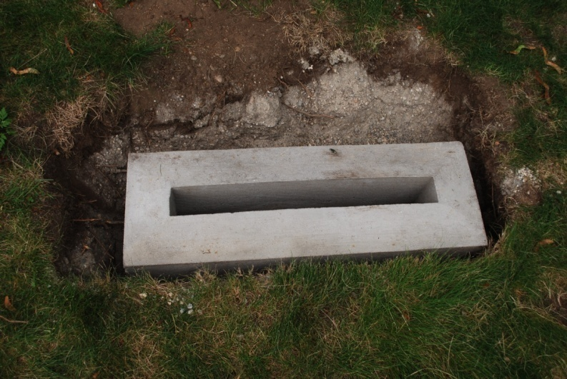
Some conservation specifications recommend squaring the bottom of the stone by cutting the stone with a saw. This is not recommended as the use of power tools on old stones can cause damage to the stone. In addition valuable history including inscriptions may be lost. If the bottom of the stone is not square a base with the same dimensions as above should be made but the slot should go completely through the base. This allows the excess stone to be partially under the base level if needed and provides for better support.
Restoration mortar repair
Repairs to gravestones, generally involves reassembly of broken pieces and fragments of stone, filling open joints, cracks and delaminating. Depending on the stone and type of break will determine which method of reattachment.
Structural reattachment
Broken stones to be bonded should be carefully cleaned and dry fitted to insure proper fit. The area around the stone should be probe for any missing pieces which may belong to the stone.
Traditional method of two part epoxy (Aboweld 55-22, Abatron) is the common way of bonding stones that require structural integrity. Epoxy is very strong although it also is moisture insensitive. This has the effect of creating a moisture barrier at the repair joint. For marble stones this can cause stone degradation over time due to the inability of the moisture to wick away from the area. Field observations have shown that failures usually occur adjacent to the repair joint which has been attributed to the strength of the epoxy being stronger than the marble. Closer observations have shown that the stone at the new break is usually degraded. Epoxy should be reserved for conditions where high shear forces are acting on the stone. Several factors such as angle of break, thickness of the stone, weight and bonding surface area need to be considered when deciding to use epoxy.
For most bonding applications, a non polymer, cement based restoration mortar (Jahn Restoration Mortars, Cathedral Stone) should be used. The specific bonding method should conform to the manufacturer’s specifications for the specific stone and should be performed by a certified Jahn Products Technician. Bonding with restoration mortars is preferable since the mortars are permeable to moisture and allow the stones to breath. Over time the stone integrity is maintained and should last longer than the epoxy. Restoration mortars should be tinted to match the stone color and texture after cleaning. Tinting can be achieved through appropriate pigments (alkali stable oxides) which are available through Cathedral Stone or mason supply.
Reinforcement
The routine use of pins has been the traditional way of reinforcing broken stones. This method is in debate and controversial. The use of pins should be avoided except in some very extreme situations where it is unavoidable. Generally, the use of pins is to provide extra support to keep two pieces together. If the stone begins to lean and the adhesion joint fails between the stones, then the pins are carrying the full weight of the stone. The pin extends the moment arm which can cause a large blow out on the face of the stone next to the pin.
If pins are required then stainless steel threaded rods ranging from 3/8”-3/4” diameter should be used. Stones should be drilled using a wet coring drill and at a slow speed. Pins are then secured using an epoxy structural adhesive.

Repair mortars/ crack fillers
Areas of missing stone can be filled using commercially available restoration mortars (Jahn Restoration Mortars, Cathedral Stone) tinted to match the stone. Tinting can be accomplished in the same way as described above in bonding mortars. Large cracks can also be filled using the same mortars. Mortar repairs should not be performed if there is a risk of freezing temperatures within two weeks after performing work.
Filling of delaminating
Delaminating occurs in many stones typically slate and sandstone. Repair of delaminated stones is designed to adhere the separated layers and prevent water penetration. The first step is to thoroughly clean the interior surfaces of the crack to remove debris. Depending on the nature of the crack, hand tools and compressed are can be used to clean out the area. Interior surfaces should then be wetted with water or a solution of water and isopropanol. For cracks larger than a 1/8” commercially available M40 flowable grout (Cathedral Stone) can be used. For smaller cracks M32 can also be used. Grouts should be tinted to match the stone after cleaning. Flowable grouts should be applied using manufacturers recommendations.

Products/Suppliers

JahnTM Restoration Mortars - M120, M160 BL, M70
M40 & M32 Flowable Grouts
From: Cathedral Stone Products Inc.
7266 Park Circle Drive
Hanover, MD 21076
800 684-0901 fax 800 684-0904

Aboweld
From: Abatron, Inc.
5501 95th Avenue
Kenosha, WI 66046
262 653-2000 fax 262 653-2019

Conservare OH100
From: Prosoco, Inc.
3741 Greenway Circle
Lawrence, KS 66046
800 255-4255 fax 800 877-2700

Additional information/websites

Association for Gravestone Studies
101 Munson Street
Suite 108
Greenfield, MA 01301
www.gravestonestudies.org

NCPTT
National Center for
Preservation Technology & Training
645 University Parkway
Natchitoches, LA 71457
www.ncptt.nps.gov

Chicora Foundation Inc.
P.O.Box 8664
Columbia, SC 29202
www.chicora.org

THE RECORDING OF A CEMETERY
By Thelma Greene Reagan

Today we walked where others walked
On a lonely, windswept hill;
Today we talked where others cried
For loved ones whose lives are stilled.

Today our hearts were touched
By graves of tiny babies;
Snatched from the arms of loving kin,
In the heartbreak of the ages.

Today we saw where the grandparents lay
In the last sleep of their time;
Lying under the trees and clouds
Their beds kissed by the sun and wind.

Today we wondered about an unmarked spot;
Who lies beneath this hallowed ground?
Was it a babe, child, young or old?
No indication could be found.

Today we saw where Mom and Dad lay.
We had been here once before
On a day we’d all like to forget,
But will remember forever more.

Today we recorded for kith and kin
The graves of ancestors past;
To be preserved for generation hence,
A record we hope will last.

Cherish it, my friend; preserve it, my friend,
For stones sometimes crumble to dust
And generations of folks yet to come
Will be grateful for your trust.

