CONSERVATION METHODOLOGY

CLEANING

Cleaning gravestones is generally not recommended unless performing repairs. Biological soiling will degrade stone surfaces over a long time. The affects of this degradation needs to be weighed against the degrading affects of cleaning. Depending on the method of cleaning this can be beneficial or detrimental.

If cleaning is necessary the stone surfaces should be rinsed with a generous amount of water and brushed with a natural bristle brush. Repeat as necessary. If a stone has biological growth, it can be treated with an anti-biological solution. D2 is the recommended product for this application.

Removal of failed repairs

Repairs are considered as having failed if they are no longer functional, are unsightly, or are a hazard. Failed adhesives, mortars and pins require careful removal before proceeding with conservation treatment. Some temporary stabilization may be necessary as poorly attached fragments are disassembled.

Removal of degraded structural resins may be particularly difficult and time-consuming. Mechanical removal is generally done with small hand tools. The cutting of pins and fasteners may require power tools. Ferrous metal pins are most often locked in place by corrosion expansion. Their removal is best done by careful drilling with a properly sized coring bit.

RESETTING

Eighteenth and early nineteenth century New England gravestones are typically stone tablets that were set directly in the ground. By the first half of the 19th century many headstones began to use bases. Stones were either mortared into slots or pined to the base. In some cases older tablets were cut and reset with a base.

Larger monuments are often made of several elements and can be both large and heavy. Specialized hoisting equipment is often required. Competent operation and structural engineering considerations are required when performing this work.

Resetting in ground

Tilted stones set directly in the ground can be made plumb by careful excavation of the soil with hand tools, to permit re-setting in the proper position and drainage. When excavating, all large stones should be removed as ice heaves can cause an underground stone to push on the gravestone. If there is not an adequate length of below grade material to support the marker a new cast concrete below grade base will be required. Once the stone is carefully placed into the vertical position and at the proper depth, the stone is made plumb and level, and aligned with adjacent markers. Backfill with a mixture of course sand and pea gravel wetted and compacted. Disturbed areas of the ground are re-graded with topsoil and seeded as required.

Resetting on/in existing base

Unsecured stones in existing bases require re-setting. Generally the base should be reset level and aligned with adjacent stones. Pins should be removed if present. The stone can then be re-set level and plumb in the existing slot.

Re-set stone on a full bed of modified lime (or hydraulic lime) mortar. Historically ratios of 1 part cement, 4 parts lime and 8 parts fine sand have been used with reasonable results. This mix is generally considered to be a soft mortar. Some conservation recommendations have specified ratios as high as 3 parts cement, 2 parts lime and 8 parts sand. The increased cement and reduced lime content has the effect of increasing the strength and adhesion of the mortar. In theory this would tend to make the mortar last longer than the traditional mix. The negative aspect is that the higher cement ratio produces a harder joint which induces a compression stress on the stone as the stone swells with varying weather conditions.

Our recommendation is to use 2 parts cement, 4 parts lime and 8 parts fine sand which, increases the strength somewhat while still retaining some of the softer properties to help reduce stress on the stone.

Resetting into new cast concrete base

There are several situations where a new cast base will be required. Usually tablets which are broken near grade level or have been cut years earlier and set into bases that have failed are typical examples of when a new base is needed. Bases can be set above grade or below depending on the stone, aesthetics or other factors. Bases can be cast on site or pre-cast and set in place on a level bed of gravel and sand.

Cast concrete bases are typically made with a slot that is ½” wider and thicker than the stone and is recessed 3”-4”. Depending on the size of the stone the base is usually 8”-12” deep, 8”-12” greater thickness and 6”-8” wider than the stone. This method is fine when resetting stones with a square bottom.

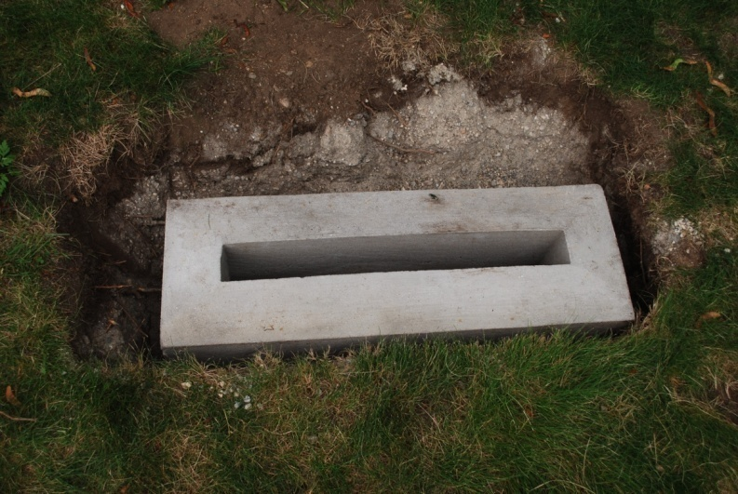

Some conservation specifications recommend squaring the bottom of the stone by cutting the stone with a saw. This is not recommended as the use of power tools on old stones can cause damage to the stone. In addition valuable history including inscriptions may be lost. If the bottom of the stone is not square a base with the same dimensions as above should be made but the slot should go completely through the base. This allows the excess stone to extend under the base level if needed and provides for better support.

Restoration mortar repair

Repairs to gravestones, generally involves reassembly of broken pieces and fragments of stone, filling open joints, cracks and delaminating. Depending on the stone and type of break will determine which method of reattachment.

Structural reattachment

Broken stones to be bonded should be carefully cleaned and dry fitted to insure proper fit. The area around the stone should be probe for any missing pieces which may belong to the stone. Traditional method of two part epoxy (Aboweld 55-22, Abatron) is the common way of bonding stones that require structural integrity. Epoxy is very strong although it also is moisture insensitive. This has the effect of creating a moisture barrier at the repair joint. For marble and slate stones this can cause stone degradation over time due to the inability of the moisture to wick away from the area. Field observations have shown that failures usually occur adjacent to the repair joint which has been attributed to the strength of the epoxy being stronger than the marble. Closer observations have shown that the stone at the new break is usually degraded. Epoxy should be reserved for conditions where high shear forces are acting on the stone. Several factors such as angle of break, thickness of the stone, weight and bonding surface area need to be considered when deciding to use epoxy.

For most bonding applications, a non polymer, cement based restoration mortar (Jahn Restoration Mortars, Cathedral Stone) should be used. The specific bonding method should conform to the manufacturer’s specifications for the specific stone and should be performed by a certified Jahn Products Technician. Bonding with restoration mortars is preferable since the mortars are permeable to moisture and allow the stones to breath. Over time the stone integrity is maintained and should last longer than the epoxy. Restoration mortars should be tinted to match the stone color and texture after cleaning. Tinting can be achieved through appropriate pigments (alkali stable oxides) which are available through Cathedral Stone or mason supply.

Reinforcement

The routine use of pins has been the traditional way of reinforcing broken stones. This method is in debate and controversial. The use of pins should be avoided except in some very extreme situations where it is unavoidable. Generally, the use of pins is to provide extra support to keep two pieces together. If the stone begins to lean and the adhesion joint fails between the stones, then the pins are carrying the full weight of the stone. The pin extends the moment arm which can cause a large blow out on the face of the stone next to the pin.

If pins are required then stainless steel threaded rods ranging from 3/8”-3/4” diameter should be used and should never exceed 1/3 of the thickness of the stone. Stones should be drilled using a wet coring drill and at a slow speed. Pins are then secured using an epoxy structural adhesive.

Repair mortars/ crack fillers

Areas of missing stone can be filled using commercially available restoration mortars (Jahn Restoration Mortars, Cathedral Stone) tinted to match the stone. Tinting can be accomplished in the same way as described above in bonding mortars. Large cracks can also be filled using the same mortars. Mortar repairs should not be performed if there is a risk of freezing temperatures within two weeks after performing work.

Filling of delaminating

Delaminating occurs in many stones typically slate and sandstone. Repair of delaminated stones is designed to adhere the separated layers and prevent water penetration. The first step is to thoroughly clean the interior surfaces of the crack to remove debris. Depending on the nature of the crack, hand tools and compressed are can be used to clean out the area. Interior surfaces should then be wetted with water or a solution of water and isopropanol. For cracks larger than a 1/8” commercially available M40 flowable grout (Cathedral Stone) can be used. For smaller cracks M32 can also be used. Grouts should be tinted to match the stone after cleaning. Flowable grouts should be applied using manufacturers recommendations.

Products/Suppliers

JahnTM Restoration Mortars - M120, M160 BL, M70
M40 & M32 Flowable Grouts
From: Cathedral Stone Products Inc.
7266 Park Circle Drive
Hanover, MD 21076
800 684-0901 fax 800 684-0904

Aboweld
From: Abatron, Inc.
5501 95th Avenue
Kenosha, WI 66046
262 653-2000 fax 262 653-2019

Conservare OH100
From: Prosoco, Inc.
3741 Greenway Circle
Lawrence, KS 66046
800 255-4255 fax 800 877-2700

